LABORATORY CHAPTER №13

TOPIC. ELECTRONICS TECHNOLOGIES

Electronics Technology (e-technologies) is a growing industry that is expanding rapidly into many areas within telecommunications, business and automation, etc. Industry and businesses rely on electronics technology for creating, manufacturing, and maintaining industrial machinery and processes. Companies can reduce costs and increase output by hiring electronics technology experts to implement robotics, automation, programming and analysis of manufacturing processes.

E-business
The appearance and development of the Internet, the improvement of information technologies, systems and standards of their interaction led to the creation of a new line of modern business - e-business as a special form of business, which is realized to a wide extent, through the introduction of information technologies into the production, sale and distribution of goods and services.
Electronic business (e-business) is the implementation of business processes using the capabilities of information and telecommunication technologies, systems and networks. The most important component of e-business is e-commerce. E-commerce refers to any form of transaction in which the parties interact with the use of information and telecommunications technology capabilities of systems and networks.

E-Learning
In recent years the term «e-Learning» has been widely used, meaning the process of learning in electronic form via the Internet. The system of electronic education is a software and hardware complex that is distributed between servers and client computers. Data exchange in the educational subnet is carried out, via Internet channels and local network communications.
The management of this multi-level hierarchical system is performed using special software platforms, which in English-language publications are called virtual learning environment (VLE) or learning management systems (LMS). One of the sources of knowledge in E-Learning is an electronic textbook - this is an electronic educational publication. It contains a systematic presentation of an academic discipline, its sections, parts, corresponding to the curriculum, supporting main links in a didactic cycle of the learning process, which is an important component of the individual active educational environment and officially approved as the type of publication.

E-government
In Kazakhstan, the idea of creating an electronic government was first voiced by the head of state Nursultan Nazarbayev in 2004. In the same year, the E-Government Formation Program was approved in the country, defining its main stages. In 2006, the e-government portal of the Republic of Kazakhstan was launched for the first time.
E-government portal of the Republic of Kazakhstan (www.egov.kz) is the information-reference and interactive web portal, providing public services and services in electronic form and providing a single point of access for the most relevant information on public services.
Descriptions of public services, divided by sections, consist of the following information:
- Full and short name of the service;
- Name of a state body (organization) - the service provider;
- Information about places where you can get information on the procedure for the provision of services;
- Category of recipients of services;
- The term of service;
- The cost of the service;
- Actions and data necessary for services in electronic form;
- List of documents required to obtain the services of a public body;
- Application forms and other documents which the applicant has to fill;
- The result of the provision of services;
- A list of texts and regulations governing the provision of services.
Each sub-section of the portal contains useful articles on common issues for obtaining government services and various ancillary information on topics subsections.
There is a constant improvement and optimization of processes. For example, the procedure for registering a business has been significantly simplified. Previously, this process was very difficult and long, took more than 30 days, but now due to the integration of systems - no more than 4 hours.

The structure of the main elements of e-government of the Republic of Kazakhstan:
1
2
3
4
6
5
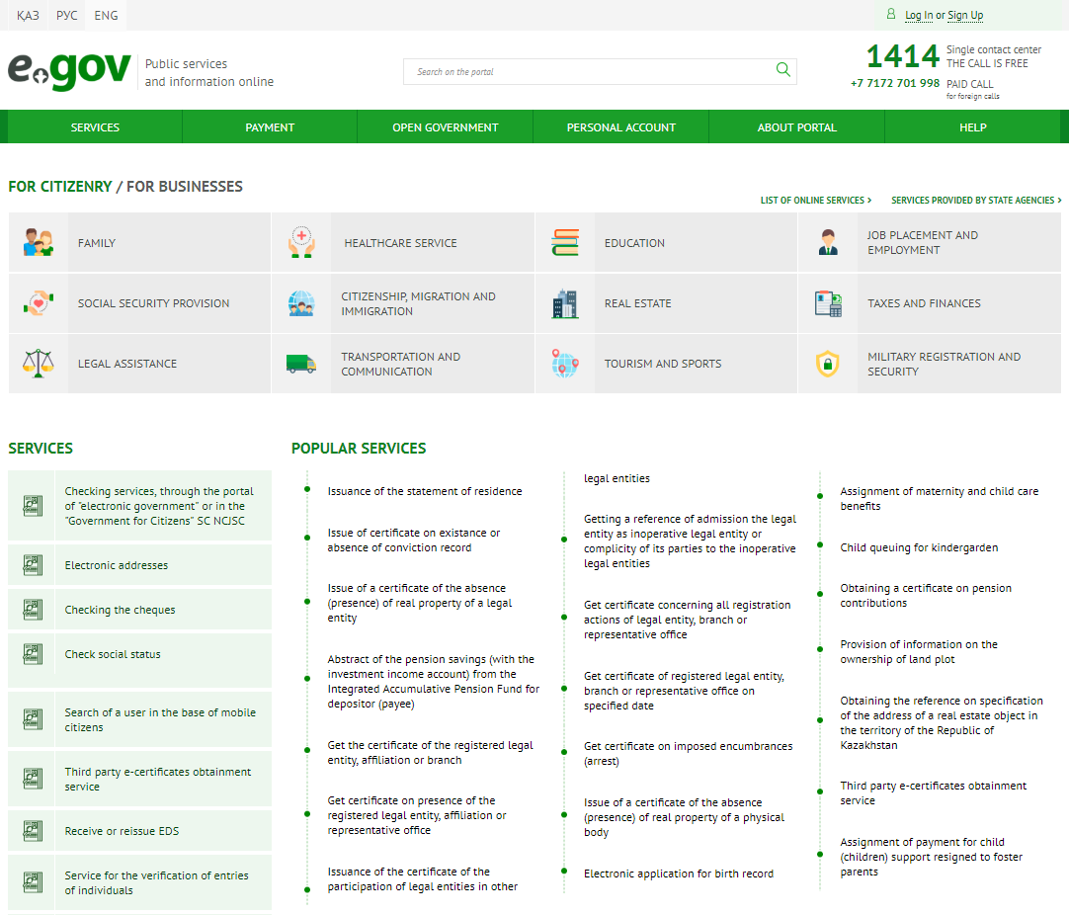
NOTE: The procedure for registration and work on the portal can be changed. For stable access and error prevention, refer to the current manuals posted on the portal.

- Login and register on the portal
To receive services on the portal, you must pass authorization. Currently, there are two ways to log in:
- Through IIN - individual identification number (permanent or one-time access)
- Via EDS - electronic digital signature (on removable media or sim card)

- Receiving or re-issuing EDS
Electronic digital signature (EDS) is designed to identify the person who signed the electronic document, and is analogous to the signature of the individual/legal entity when writing documents online.

- Getting background information on working with the portal
To get help on working with the portal, do the following:
- Click on the "Help" button on the main page of the portal
- Select “Instructions”, “Frequently Asked Questions” or “Tutorials”
- You can also ask your question by contacting the operator at the specified phone number

4. Receipt of services and references on the portal:
For citizenry/Businesses services, do the following:
- Select a group of services for individuals (citizens) or legal (business) persons on the
main page of the portal
- Select a service group from the list and click its shortcut

On the service page that opens, select the required category from the list on the right

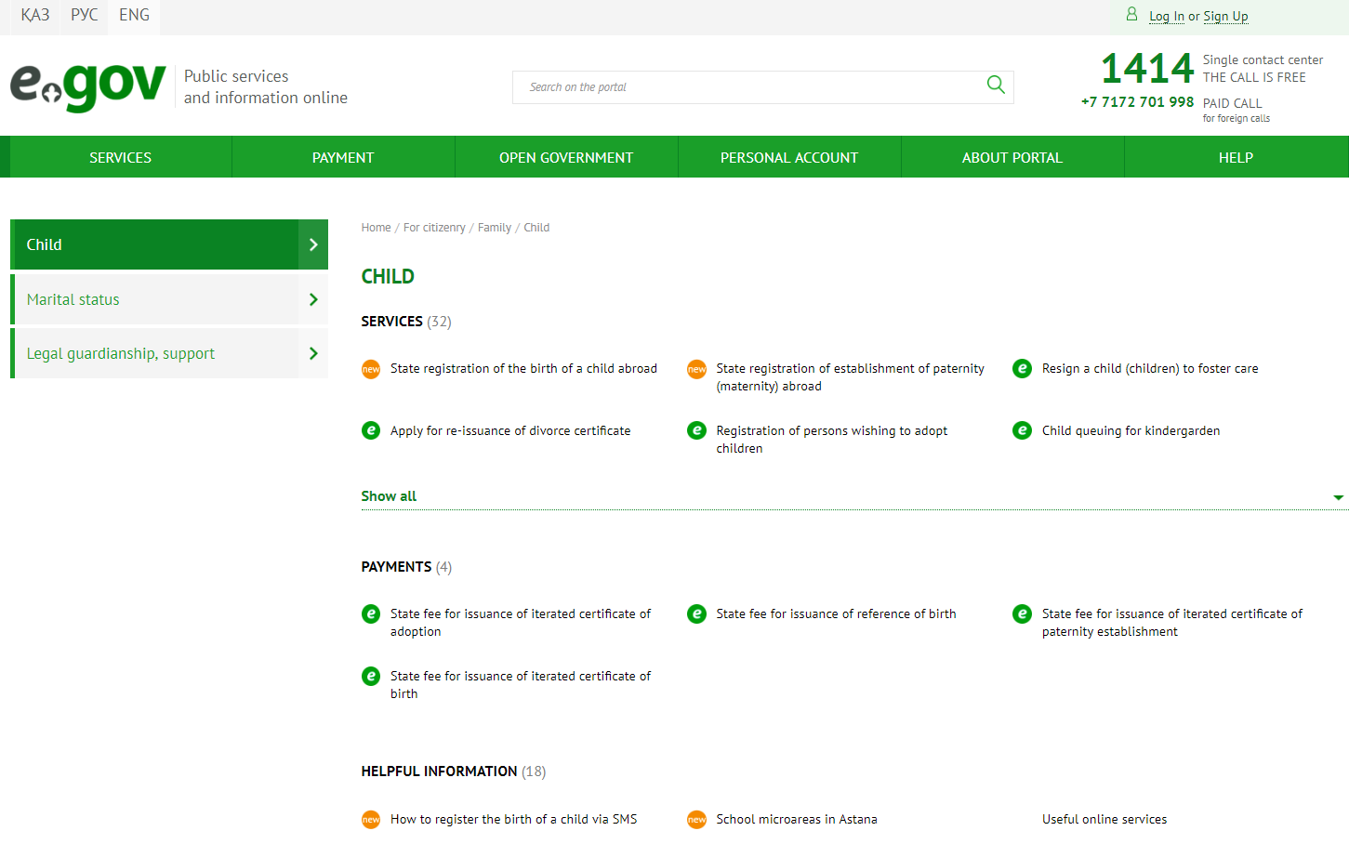
- The “Services” category lists the services provided in this category
- In the category "payment" you can get information about the payment procedure (including the availability of the service for payment online) and carry out a payment transaction
- To get help information on services, select a document from the Useful Information category.

- Receipt of reference and statistical information about the Republic of Kazakhstan, the
Constitution, etc.
To get information on government its structure, etc. do the following:
- Click on the “Open Government” link on the main portal page or on one of the links in this category. When clicking on the link “State bodies of the Republic of Kazakhstan”, a new page will open with information about the Constitution, Symbols, Ministries of the Republic of Kazakhstan, etc.
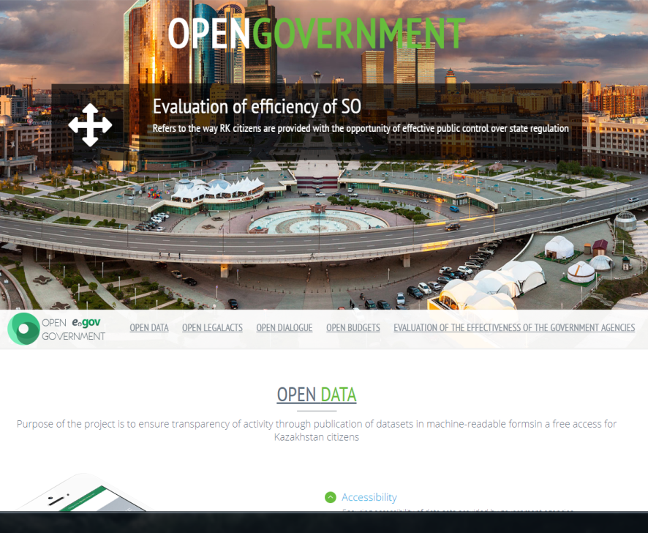
- To get statistical information on the work of government agencies, as well as access to current news, click on the “Open data” link and in the opened window select the required category

6. Keyword Search
- For a quick search, enter a keyword in the search bar on the main page.
- Select the most appropriate category from the "All Matches" list.

